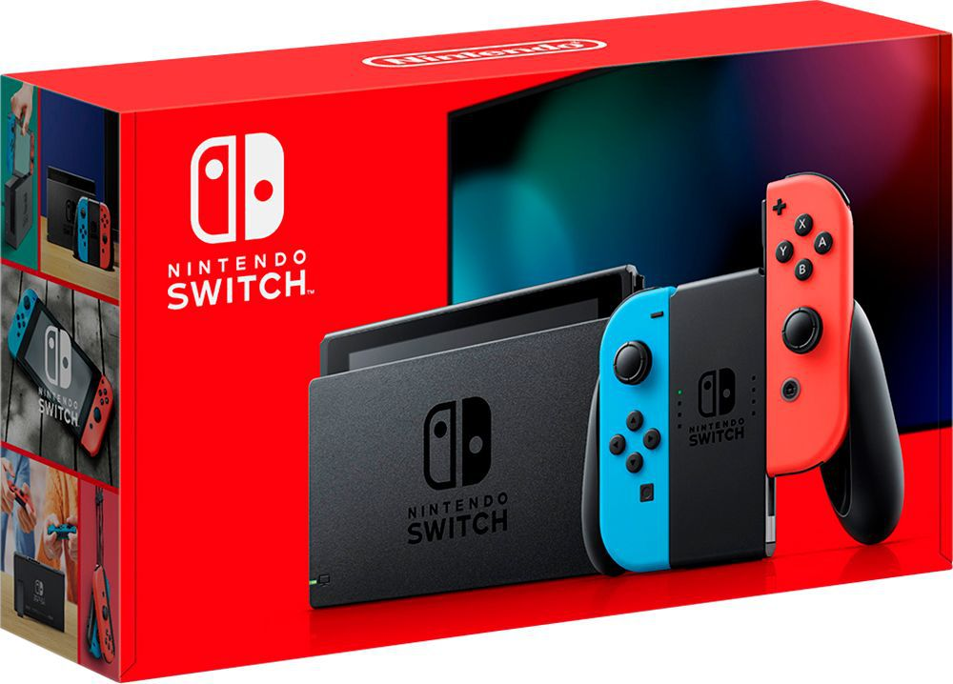

**Nintendo Switch**

**Price: $350**

**Description:** The Nintendo Switch[h] is a video game console developed by Nintendo and released worldwide in most regions on March 3, 2017. The console itself is a tablet that can either be docked for use as a home console or used as a portable device, making it a hybrid console.

**System Specifications:**

* CPU / GPU: NVIDIA Custom Terga processor
* Storage: 64 GB -- Users can easily expand storage space using microSDHC or microSDXC cards up to 2TB (sold separately).

**Developed By:**

